SE-317 — Software Project Management
Stage 04 — Project Budget Documentation
Part B: Step-by-Step Preparation of the Project Budget Sheet
Project Title: Integrated Gym Management System
Name | Registration No.
Hadia Nasir | 231400100
Ahmad Khan | 231400101
Muneeb Akram | 231400103
Haider Zaman | 231400106

1. Introduction
This document explains, step by step, how the Project Budget Sheet for the Integrated Gym Management System was prepared in Microsoft Excel for Stage 04 of the SE-317 Software Project Management project. The budget sheet converts the project schedule (task durations from the Microsoft Project file) into estimated hours, applies hourly billing rates to calculate the cost of each task and each team member, and finally rolls all figures up into a single Total Project Budget. Excel formulas such as multiplication, SUM, and division were used throughout so that the budget updates automatically if any input value changes, and three charts were created to visualise the cost distribution.

2. Overview of the Budget Sheet
The completed workbook (Stage4.xlsx) contains a single worksheet with four main sections: an hours-conversion reference, the Task Cost Estimation table, the Resource Cost Estimation table, and the Total Project Budget summary, alongside three charts. The full layout is shown below.
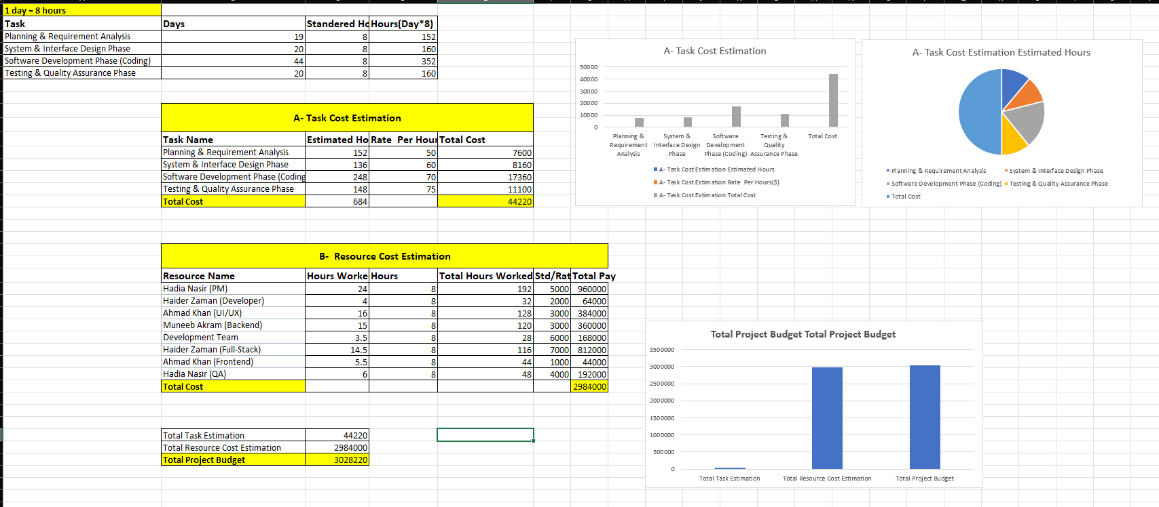

Figure 1: Complete Project Budget Sheet with data tables and charts

3. Step-by-Step Preparation

Step 1 — Converting Task Durations into Standard Hours
The task durations (in days) were taken directly from the project schedule created in Microsoft Project during Stage 02/03. Since costing needs to be done on an hourly basis, a simple reference rule of 1 day = 8 hours was applied. A column was added for each of the four project phases (Planning & Requirement Analysis, System & Interface Design, Software Development/Coding, and Testing & Quality Assurance), and the formula = Days * Standard Hours was used to compute the total hours for each phase.
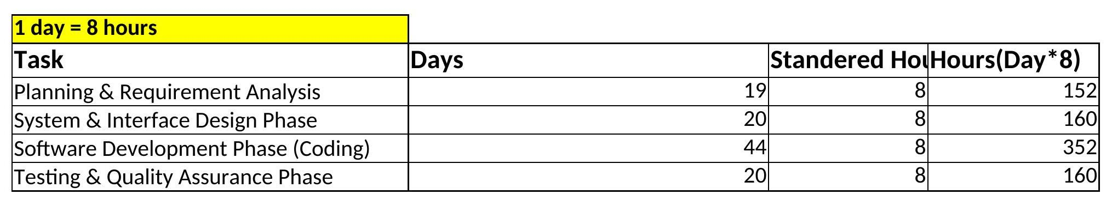

Figure 2: Converting task duration (days) into standard hours using =B*C
- Formula used: D3 = B3*C3 (Days × 8 standard hours per day)
- This is repeated for all four phases (rows 3–6).

Step 2 — Task Cost Estimation (Section A)
The estimated hours for each phase (calculated in Step 1) were carried into the Task Cost Estimation table together with an hourly billing rate that reflects the complexity/skill level of that phase (e.g., $50/hr for planning versus $75/hr for testing). The Total Cost per task was then computed automatically.
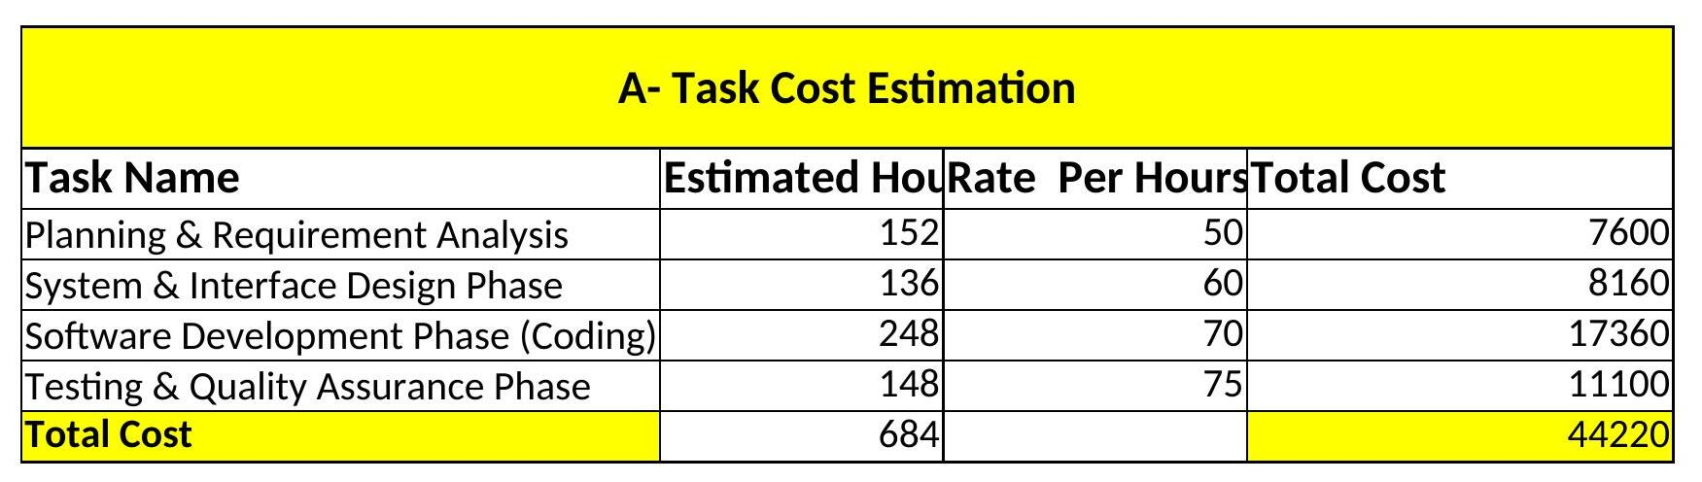

Figure 3: Task Cost Estimation table with Estimated Hours × Rate = Total Cost
- Formula used: E12 = C12*D12 (Estimated Hours × Rate per Hour)
- Formula used: C16 = SUM(C12:C15) — total estimated hours across all tasks
- Formula used: E16 = SUM(E12:E15) — total task-based cost

Step 3 — Resource Cost Estimation (Section B)
A second table was built to estimate cost from the perspective of individual team members/resources rather than tasks. For each resource, the total hours worked and a standard pay rate were recorded, and Excel formulas were used to derive the number of working days and the total pay for each resource.
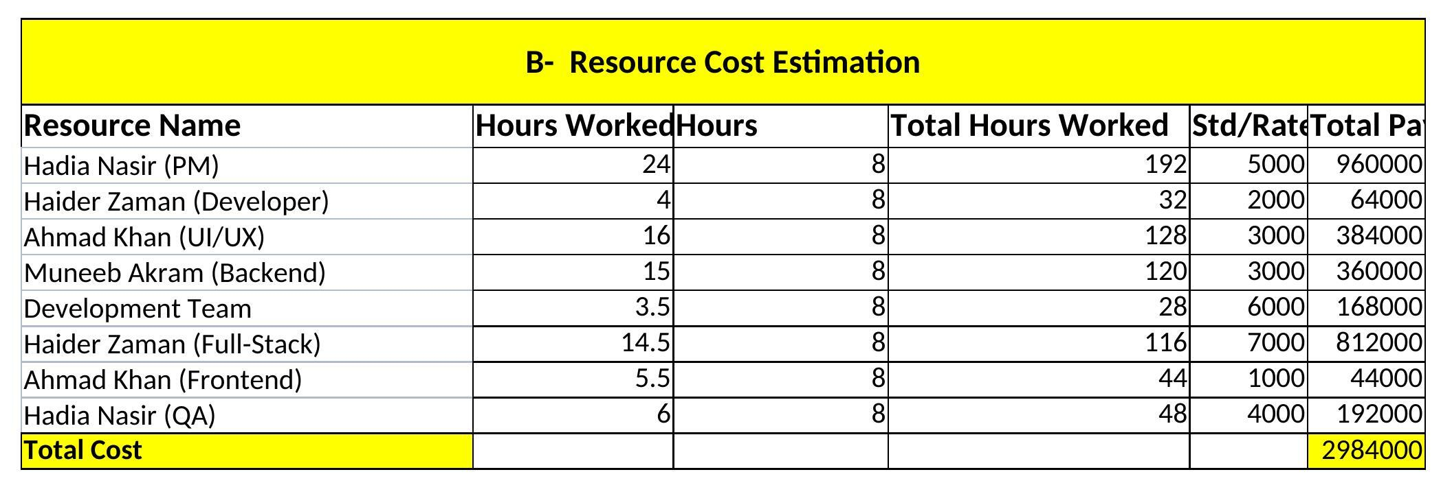
Figure 4: Resource Cost Estimation table listing each team member, hours worked, and pay
- Formula used: C23 = E23/D23 (Total Hours Worked ÷ Hours per Day = Days Worked)
- Formula used: G23 = F23*E23 (Rate × Total Hours Worked = Total Pay)
- Formula used: G31 = SUM(G23:G30) — total resource-based cost

Step 4 — Total Project Budget
Finally, the two independent estimates — the Total Task Estimation (Section A) and the Total Resource Cost Estimation (Section B) — were linked together and summed to produce the single Total Project Budget figure for the project.
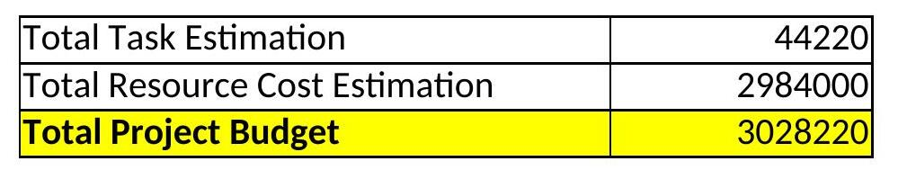
Figure 5: Final Total Project Budget calculated with a SUM formula
- Formula used: C35 = E16 (link to Total Task Estimation)
- Formula used: C36 = G31 (link to Total Resource Cost Estimation)
- Formula used: C37 = SUM(C35:C36) — Total Project Budget

Step 5 — Formatting the Sheet
To make the budget sheet easy to read and professional in appearance, the following formatting was applied:
- Bold, coloured section headings for "A - Task Cost Estimation" and "B - Resource Cost Estimation".
- Table borders around every data range to visually separate rows and columns.
- Header rows shaded/bolded to distinguish column titles from data (Task Name, Estimated Hours, Rate per Hour, Total Cost, etc.).
- Currency-style number formatting on all cost columns and consistent column widths for readability.

Step 6 — Creating Graphical Representations (Charts)
Three charts were inserted using Excel's Insert → Chart feature to visualise the cost distribution across tasks, resources, and the overall budget, satisfying the requirement for at least two graphical representations.
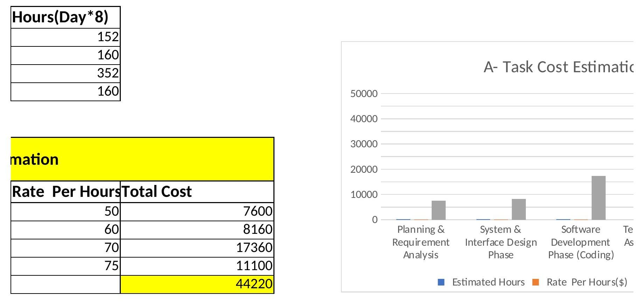
Figure 6: Column chart — "A - Task Cost Estimation" showing cost per project phase
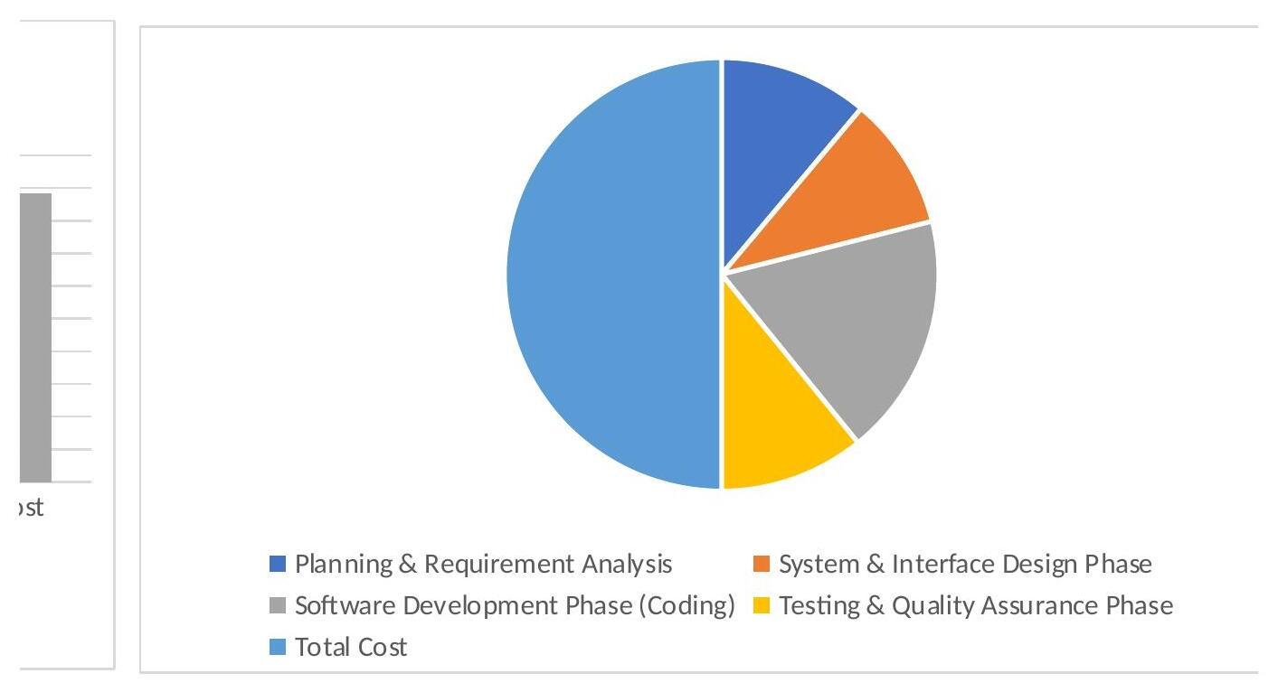
Figure 7: Pie chart showing the proportional cost distribution of each task
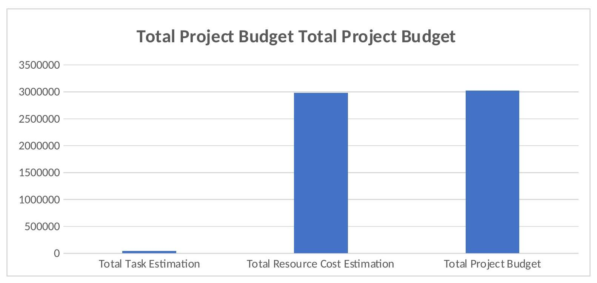

Figure 8: Column chart summarising the Total Project Budget components

4. Summary of Formulas Used
Step | Description
1 | PRODUCT / " * " — used to multiply Days × Standard Hours, and Hours × Rate, to calculate cost values.
2 | SUM — used to total the Estimated Hours, Total Cost, Total Pay, and the final Total Project Budget.
3 | Division ( / ) — used to convert Total Hours Worked back into working days for each resource.
4 | Cell referencing (e.g., C35 = E16) — used to link the Task Cost and Resource Cost sections into the final budget summary.

5. Conclusion
By combining schedule data from Microsoft Project with Excel formulas for multiplication, summation, and cell linking, the Project Budget Sheet accurately calculates the estimated cost of the Integrated Gym Management System from both a task-based and a resource-based perspective. The accompanying column and pie charts make the cost distribution easy to interpret at a glance, completing the requirements of Stage 04 – Part A and Part B.

